Security Identity and Access Management (SIAM)

Security Identity and Access Management (SIAM) systems can vary based on their specific functionalities, deployment models, and the particular use cases they address. Here are some of the different types of SIAM systems:
1. Enterprise Identity and Access Management (IAM)
- Purpose: Primarily used within large organizations to manage employee access to internal systems and resources.
- Key Features:
  - Single Sign-On (SSO)
  - Role-Based Access Control (RBAC)
  - Multi-Factor Authentication (MFA)
  - Provisioning and de-provisioning of user accounts
  - Integration with enterprise directories (e.g., Active Directory)
- Examples: Microsoft Azure AD, Okta Workforce Identity, IBM Security Identity Manager
2. Customer Identity and Access Management (CIAM)
- Purpose: Focused on managing the identities and access of customers (external users) rather than internal employees.
- Key Features:
  - Self-service registration and profile management
  - Social login (integration with social media accounts)
  - Consent management for data privacy regulations (e.g., GDPR)
  - Personalization based on customer profiles
  - Scalability to handle large numbers of users
- Examples: Okta Customer Identity, Auth0, ForgeRock Identity Platform
3. Privileged Access Management (PAM)
- Purpose: Specifically designed to manage and secure access to privileged accounts that have elevated permissions, such as system administrators or superusers.
- Key Features:
  - Secure storage and management of privileged credentials
  - Session monitoring and recording for audit purposes
  - Just-in-time access provisioning
  - MFA for privileged accounts
  - Risk-based access control
- Examples: CyberArk, BeyondTrust, Thycotic
4. Identity Governance and Administration (IGA)
- Purpose: Focuses on governing and managing user identities and access rights across an organization to ensure compliance and minimize risk.
- Key Features:
  - Automated user provisioning and de-provisioning
  - Access certification and review processes
  - Role management and role mining
  - Policy enforcement and audit trails
  - Compliance reporting
- Examples: SailPoint, RSA Identity Governance and Lifecycle, Oracle Identity Governance
5. Federated Identity Management
- Purpose: Enables users to authenticate and access resources across multiple domains or organizations using a single identity, often across organizational boundaries.
- Key Features:
  - Trust relationships between organizations
  - Use of standards like SAML, OAuth, and OpenID Connect
  - Single Sign-On (SSO) across federated domains
  - Cross-domain identity management
- Examples: Ping Identity, ADFS (Active Directory Federation Services), Shibboleth
6. Cloud-Based Identity and Access Management
- Purpose: Manages identities and access in cloud environments, often provided as a service (IDaaS).
- Key Features:
  - Integration with cloud applications and services
  - Identity federation and SSO for cloud applications
  - Scalability and availability managed by the provider
  - API-based identity management for cloud-native applications
- Examples: Okta, Microsoft Azure AD, Google Cloud Identity
7. Biometric Identity Management
- Purpose: Uses biometric data (e.g., fingerprints, facial recognition, iris scans) for authentication and identity verification.
- Key Features:
  - Biometric data capture and storage
  - Biometric-based authentication and identity proofing
  - Integration with physical and digital access control systems
  - Enhanced security through unique, non-replicable identity factors
- Examples: NEC NeoFace, Aware Biometrics, Idemia
8. Identity as a Service (IDaaS)
- Purpose: A cloud-based service that provides identity management capabilities without the need for on-premises infrastructure.
- Key Features:
  - Multi-tenant, cloud-native identity management
  - Self-service user management and authentication
  - Integration with on-premises and cloud applications
  - Continuous updates and management by the service provider
- Examples: Okta, Azure Active Directory (AAD), OneLogin
9. Decentralized Identity Management
- Purpose: Aims to give individuals control over their own identities, often using blockchain or other decentralized technologies.
- Key Features:
  - Self-sovereign identities (users own and control their digital identity)
  - Decentralized identity verification
  - Privacy-enhancing features such as zero-knowledge proofs
  - Peer-to-peer trust models
- Examples: Sovrin, uPort, Microsoft ION
10. Hybrid Identity Management
- Purpose: Combines on-premises identity management with cloud-based services to provide a unified identity solution across different environments.
- Key Features:
  - Seamless integration between on-premises and cloud identities
  - SSO and MFA across hybrid environments
  - Centralized identity management with distributed deployment
  - Support for legacy systems and cloud applications
- Examples: Microsoft Azure AD with ADFS, Ping Identity, IBM Security Identity Governance and Intelligence
Conclusion
SIAM systems are diverse and cater to different needs depending on whether the focus is on employees, customers, privileged users, or federated identities across organizations. Choosing the right type of SIAM system depends on the specific requirements of the organization, such as the need for internal employee management, customer interaction, or secure privileged access. Each type has its strengths and is suited to particular use cases, from basic access control to advanced governance and compliance.

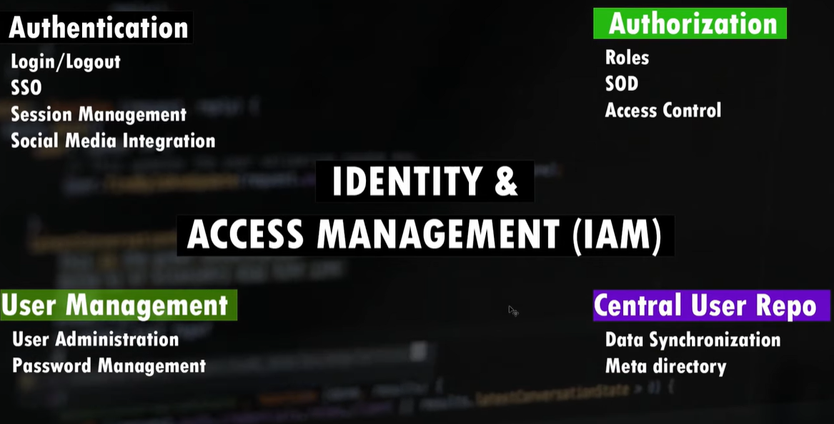
Keycloak in 5 Bullet Points
- Keycloak is an open-source authentication and authorization service for your web applications. Unlike paid services like Auth0 and Okta, Keycloak is self-hosted, giving you more control over your user data.
- Keycloak offers a wide range of features, including:
  - Login and Logout: Manage user logins and logouts, including single sign-on (SSO) across multiple applications.
  - User Management: Create, edit, and delete users, as well as manage password resets and expiration.
  - Authorization: Assign roles to users and restrict access to specific resources based on those roles. This allows you to implement different levels of access for different user types.
  - Centralized User Repository: Manage users in one place and grant them access to all your applications with a single credential.
- Keycloak is highly customizable. You can configure the login page appearance, password policies, two-factor authentication, and more through the Keycloak admin console.
- Keycloak integrates with your backend server using JSON Web Tokens (JWT). You can verify the token's validity and extract user information to personalize the user experience.
- This video tutorial demonstrates setting up a basic Keycloak server, integrating it with a React application, and securing the backend API with token-based authentication.
Upload an image
This prompt requires an image that you need to add. Tap the image button to upload an image.
Got it
Need a little help with this prompt?
Power up your prompt and Gemini will expand it to get you better results
Got it

https://www.youtube.com/watch?v=5z6gy4WGnUs
REML
    - Client

KEY CLOCK with AZURE AD - https://www.youtube.com/watch?v=LYF-NLHD2uQ

If you are currently using Azure AD for identity management and are considering implementing a role-based user management system across different systems, integrating SIAM (Service Integration and Management) could be a strategic move. SIAM is designed to manage multiple service suppliers by integrating them to provide cohesive service delivery and governance, which can be particularly beneficial in complex IT environments with multiple vendors.
Key Benefits of SIAM
- Improved Service Quality and Governance: SIAM provides a framework for managing multiple suppliers, ensuring that services are delivered efficiently and meet organizational goals. It offers improved governance and service quality by establishing clear roles and responsibilities.
- Integration and Collaboration: SIAM promotes collaboration among service providers, focusing on end-to-end service delivery rather than individual contractual targets. This approach can lead to faster resolution of issues and more innovative solutions.
- Flexibility and Scalability: The SIAM model is adaptable to organizations of any size, providing a scalable and flexible network of suppliers. This can optimize costs and increase value by leveraging specialized service providers.
SIAM Models
There are several SIAM models that you can choose from, depending on your organization's needs and capabilities:
- Internal Service Integrator: Your organization manages all vendor relationships internally, which can be cost-effective if you have the necessary expertise.
- External Service Integrator: An independent service integrator manages vendor relationships, offering significant experience but at a higher cost.
- Hybrid Service Integrator: Combines internal and external resources, allowing for a gradual transition to a fully internal model as your team gains experience.
- Lead Supplier as Service Integrator: A key supplier manages other vendors, which requires a high level of trust.
Implementation Considerations
- People, Processes, and Tools: Successful SIAM implementation relies on the right people, processes, and tools. It requires skilled individuals who can manage relationships and navigate the complexities of multi-vendor environments.
- Governance Framework: Establishing a robust governance framework is essential for overseeing service delivery and ensuring compliance with organizational needs.
- Continuous Improvement: Embedding continuous improvement processes within the SIAM framework ensures that services evolve with changing business requirements.
Adopting SIAM can help streamline your role-based user management across different systems, providing a structured approach to managing multiple service providers and enhancing overall IT service delivery.

